**TOPSTECHNOLOGIES**

**Training | Outsourcing | Placement |Study Abroad**

**Software Engineering Assignment**

**MODULE: 1**

**SE – Overview of IT Industry**

1. **What is software? What is software engineering?**
   * + Software :

* **Set of instructions executed by any kind of tool.**
  + - **Software engineering** :
* **Use of engineering principles for developing software.**

1. **Explain type of software.**

* **Type of software :**

**--------------------------**

1. **System software :----**

* **These software programs are designed to run a computer’s application programs and hardware.**
* **System software coordinates the activities and functions of the hardware and software.**
* **It controls the operations of the computer hardware and provides an environment or platform for all other types of software to work in.**
* **The Os is the best examples of system software; it manages all the other computer programs.**
* **Other examples of system software include the firmware, computer language translators and system utilities..**

**Example: Calculator, notepad, clock**

1. **Application software :-------**

* **The most common type of software, application software is computer software package that performs a specific function for a use, or in some cases, for another application.**
* **An application can be self-contained, or it can be a group of programs that run the application for the user.**
* **Examples of modern applications include office suites, graphics software , databases and database management programs, web browsers, word processors, software development tools, image editors and communication platforms**

**Example: Microsoft office, paint, PowerPoint, WhatsApp, Instagram, LinkedIn, Twitter, zoom, Maps, Drive, Gmail, etc.**

1. **Driver software :-------**

* **Also known as device drivers, this software is often considered a type of system software.**
* **Device drivers control the devices and peripherals connected to a computer, enabling them to perform their specific tasks.**
* **Every device that is connected to a computer needs at least one device driver to function.**
* **Examples include software that comes with any nonstandard hardware, including special game controllers, as well as the software that enables standard hardware, such as USB storage devices, keyboards, headphones and printers.**

**Example: Audio driver, video Driver etc**

1. **Middleware:--------**

* **The term middleware describes software that mediates between application and system software or between two different kinds of application software.**

**For example, middleware enables Microsoft windows to talk to excel and word.**

* **It is also used to send a remote work request from an application in a computer that has one kind of OS, to an application in a computer with a different OS. It also enables newer applications to work with legacy ones.**

**Example: database middleware, application server middleware**

1. **Programming software (compiler , interpreter):----------**

* **Computer programmers use programming software to write code. Programming software and programming tools enable developers to develop, write, test and debug other software programs.**
* **Examples of programming software include assembles, compilers, debuggers interpreters.**

**Examples: turbo c, Eclipse, sublime etc**

1. **What is SDLC? Explain each phase of SDLC**

* **Software development life cycle (SDLC) refers to a methodology with clearly defined processes for creating high-quality software.**

**Time line + budget + quality.**

* **A step by step approach to develop any product / software with high quality, lowest cost with shortest possible time.**
* **Phases of SDLC :­**

**­­­-------------------------**

* **The software development life cycle (SDLC) refers to a methodology with clearly defined processes for creating high – quality software. In detail, the SDLC methodology focuses on the following phases of software development:**

1. **Planning / Requirement gathering :**

**This stage involves understanding what the software needs to do by gathering requirements from stakeholders and creating a project plan with timelines and resource allocation.**

**2.) Analysis:**

**In this phase, the gathered requirements are analyzed to understand how the software will achieve its goals. Models like use case diagrams and data flow diagrams are created, and requirements are validated with stakeholders.**

**3.) Designing (DFD, flow, chart, ER, Use case):**

**Designing involves creating the system architecture and detailed design specifications. This includes making detailed diagrams and prototypes to ensure the system is well – planned before coding begins.**

**4.) Implementation / coding / Building:**

**This is the phase where developers write the actual code for the software based on the design documents. It includes setting up development environments, coding, reviewing code for quality, and integrating components.**

**5.) Testing:**

**Testing ensures the software works correctly and meets the requirements.**

**Various tests like unit, integration, system, and user acceptance tests are conducted, and any buys found are fixed.**

**6.) Maintenance:**

**After the software is deployed, this phase involves providing ongoing support, releasing updates, monitoring performance, and ensuring the software continues to function well over time. It also includes planning for the software’s end-of-life when necessary.**

1. **What is DFD? Create a DFD diagram on Flipkart.**

* **Data flow diagram (DFD) is a graphical representation of data flow in any system. It is capable of illustrating incoming data flow, outgoing data flow and store data. Data flow diagram describes anything about how data flows through the system.**

* **Components of DFD:-**

**Process:-**

**There are several ways to view these DFD components. Process. The process (function, transformation) is part of a system that transforms inputs to outputs. The symbol of a process is a circle, an oval, a rectangle or a rectangle with rounded corners (according to the type of notation).**

**Process:-**

**Data Flow:-**

**A data flow diagram (DFD) maps out the flow of information for any process or system. It uses defined symbols like rectangles, circles and arrows, plus short text labels, to show data inputs, outputs, storage points and the routes between each destination.**

**Data Flow**

**Data Store:-**

**A data store or data repository is used in a data-flow diagram to represent a situation when the system must retain data because one or more processes need to use the stored data in a later time.**

**Data store**

**External Entity:-**

* **Outside systems that send or receive data to and from the diagrammed system.**

**External Entity:-**

**DFD diagram on flipkart**

1. **Level 0 DFD**

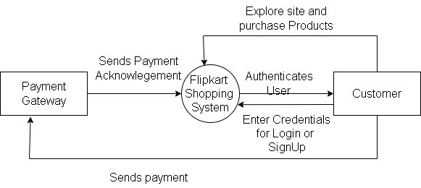

1. Level 1 DFD

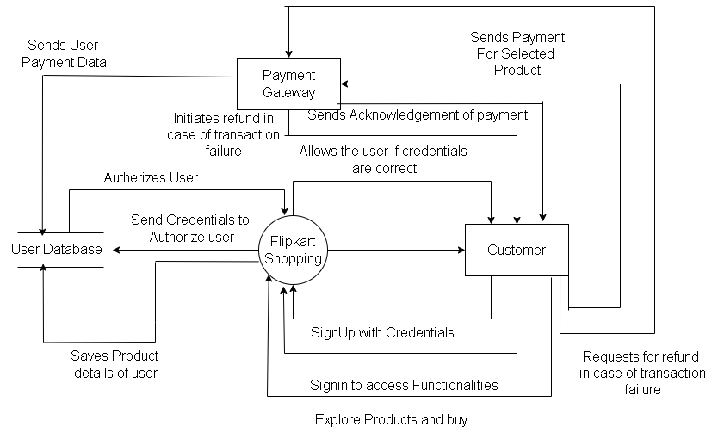

1. **Login**

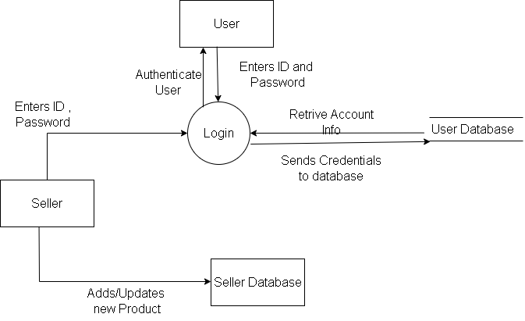

**ii) Sign Up**

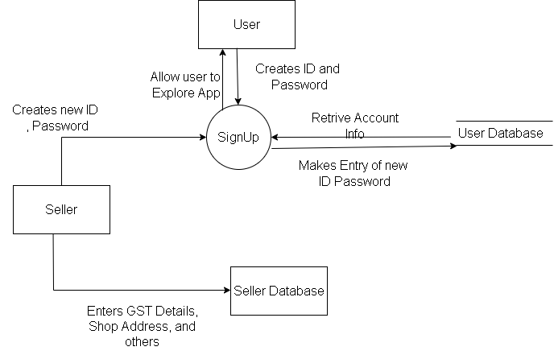

1. **Payment**

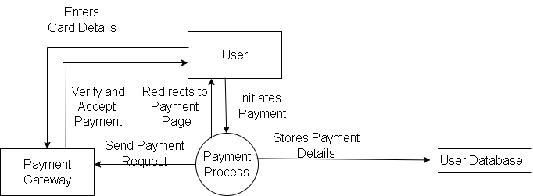

5) **What is Flow chart? Create a flowchart to make addition of two numbers**

**Answer:-**

**Representation of program by graphics with the components**

**Step 1: start the program.**

**Step 2: Get two positive numbers.**

**Step 3: Add these two numbers.**

**Step 4: Get answer for the numbers.**

**Step 5: End of the program**

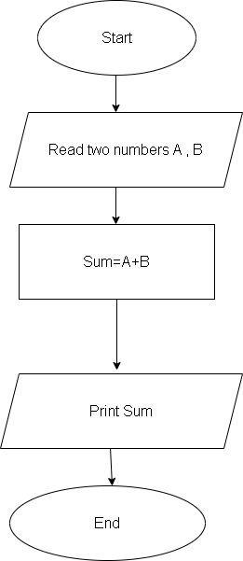

1. **What is Use case Diagram? Create a use-case on bill payment on paytm.**

**Answer:-**

**A use case diagram is a graphical depiction of a user's possible interactions with a system.**

**Components of Basic Model**

**There are various components of the basic model:**

**1. Actor**

**2. Use Case**

**3. Associations**

**Use Case Diagram for bill payment on paytm:**

